AI Assistant using Neural Networks, Large Language Models, and Reinforcement Learning
Terms of Reference (TOR) and System Design Report

Abstract
Artificial Intelligence assistants are increasingly used to support human interaction with computer systems. Traditional assistants rely on rule-based systems or large language models alone, which may lack adaptability and decision-making capabilities. This project proposes a hybrid AI assistant architecture that integrates Neural Networks for intent classification, Reinforcement Learning for response strategy selection, and Large Language Models for response generation.
The purpose of this project is to develop an intelligent system capable of understanding user queries, selecting appropriate response strategies, and generating meaningful responses. The system is designed to operate locally using downloaded models and databases. Performance is evaluated using defined Terms of Reference (TOR) metrics across three system maturity stages: Cold Start, Partial Data, and Rich Profile.

Introduction
Artificial Intelligence assistants have become an essential component of modern digital systems. These assistants can interact with users through natural language, retrieve information, and perform various tasks. However, many existing assistants rely on a single AI technique, which limits their ability to adapt and improve over time.
This project proposes a hybrid AI assistant system that integrates multiple AI technologies to improve performance and decision-making. The system combines:
- Neural Networks (NN) for classifying user intent
- Reinforcement Learning (RL) for optimizing response strategy selection
- Large Language Models (LLM) for generating natural language responses
The assistant receives user input, identifies the user's intent, selects the most appropriate response mechanism, and generates a response accordingly.

Project Objectives
The main objectives of this project are:
- Develop an intelligent AI assistant capable of understanding user queries.
- Implement a neural network to classify user intent accurately.
- Use reinforcement learning to select the best response strategy.
- Generate natural language responses using a large language model.
- Integrate multiple AI components into a single system architecture.
- Enable the system to operate locally without requiring internet connectivity.
- Improve system performance through continuous learning and user interaction.

Project Requirements
3.1 Functional Requirements
The AI assistant system must be capable of performing the following functions:
- Accept natural language input from users.
- Classify user intent using a neural network model.
- Determine the best response strategy using reinforcement learning.
- Generate responses using a large language model.
- Retrieve information from a knowledge database.
- Store and recall user interaction history.
- Provide responses through a user interface.

3.2 Technical Requirements
The project requires the following technologies:
Programming Language
- Python
Machine Learning Technologies
- Neural Networks
- Reinforcement Learning (Q-learning)
- Large Language Models
AI Frameworks and Libraries
- NumPy
- Sentence Transformers
- llama-cpp-python or Ollama
- Faster Whisper (optional voice module)
Database
- SQLite database for storing knowledge and interaction history.

3.3 System Requirements
Hardware Requirements:
- CPU: Minimum 4 cores
- RAM: Minimum 8 GB
- Storage: 10–20 GB for models
Software Requirements:
- Operating System: Windows / Linux / macOS
- Python 3.9 or higher
- Local LLM runtime (Ollama or llama.cpp)

System Functional Areas
The AI assistant system consists of several functional modules.
4.1 Intent Classification Module
This module uses a neural network to classify the user's input into predefined categories such as greeting, question, command, or knowledge request.
4.2 Decision Module (Reinforcement Learning)
The reinforcement learning module selects the most appropriate response strategy based on previous interactions and reward feedback.
4.3 Response Generation Module
This module uses a large language model to generate natural language responses.
4.4 Knowledge Retrieval Module
The system retrieves information from a local knowledge database when factual answers are required.
4.5 Memory and Personalization Module
This module stores previous user interactions to improve response relevance and personalization.

System Architecture
The system follows a modular architecture in which each AI component performs a specific function.
Figure 1: System Architecture Diagram
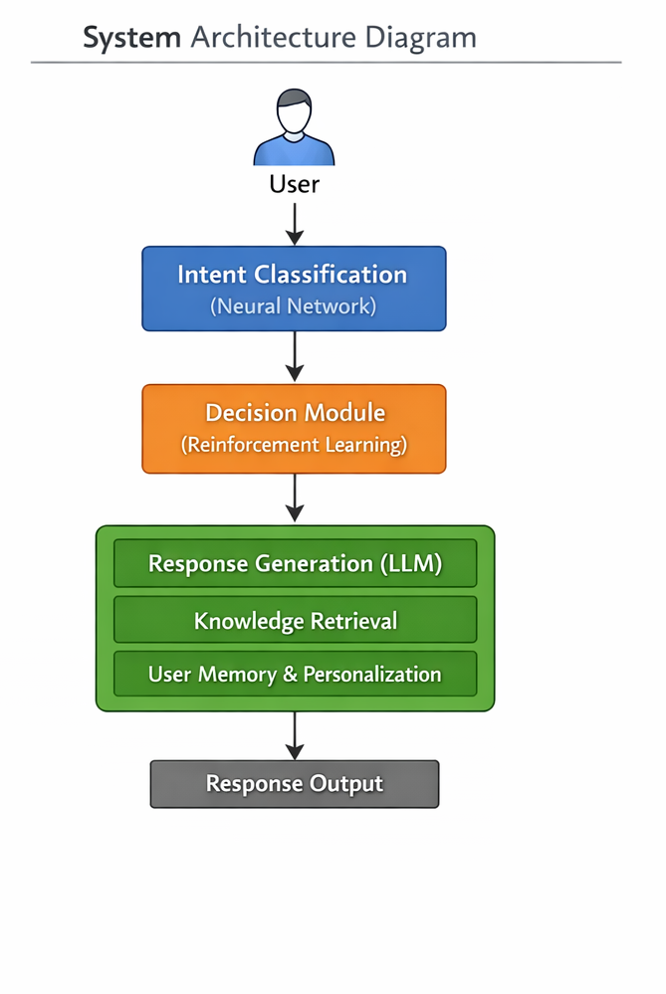
6. System Performance Stages
To evaluate the system performance, three operational stages are defined.
6.1 Cold Start
This stage occurs when the system has no interaction history or reinforcement learning experience.
6.2 Partial Data
In this stage, the system has accumulated some interaction history and begins improving its response strategy.
6.3 Rich Profile
This stage represents a mature system where sufficient user interaction data has been collected, and system performance is optimized.

TOR Metrics Table
Below is the TOR metrics transformed into the requested table format.
Functional Areas | Metrics | Cold Start | Partial Data | Rich Profile
Intent Classification | Intent prediction accuracy | 60–70% | 75–85% | ≥90%
Response Strategy Selection | Decision accuracy | 50–60% | 70–80% | ≥85–90%
Response Generation | Response quality score | ~3 | ~4 | ≥4.5
Knowledge Retrieval | Retrieval accuracy | 65–75% | 80–85% | ≥90%
System Response Time | Response latency | 2–4 sec | 1–3 sec | <2 sec
Personalization | Personalization accuracy | none | basic | high
System Reliability | Stability | 90% | 93–95% | ≥98%
RL Learning Improvement | Policy improvement | none | gradual | optimized

System Flowchart
Figure 2: AI Assistant Processing Flowchart
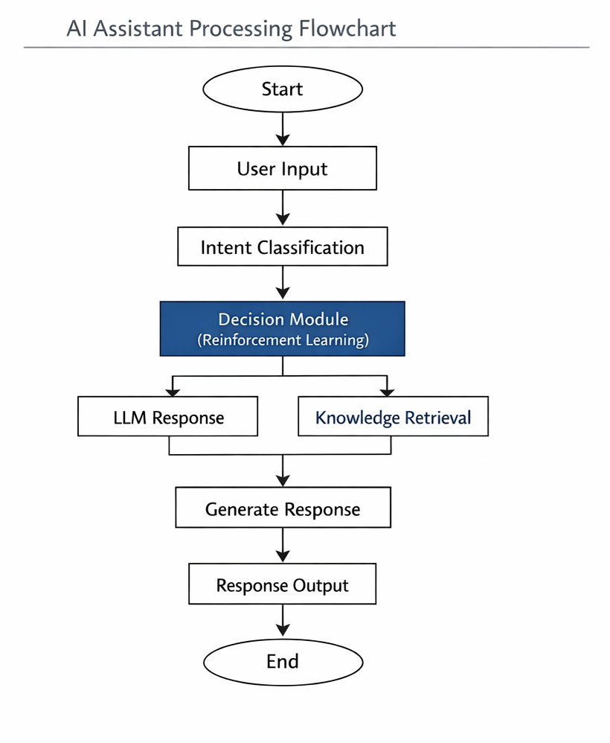

Mathematical Models Used
Neural Network
The neural network computes the weighted sum of inputs:
z = Wx + b
Activation function used:
ReLU(x) = max(0, x)

Reinforcement Learning
The Q-learning update rule is:
Q(s,a) = Q(s,a) + α [ r + γ max Q(s',a') − Q(s,a) ]
Where:
- s = state
- a = action
- r = reward
- α = learning rate
- γ = discount factor

Transformer Attention (LLM)
Attention mechanism used in transformers:
Attention(Q,K,V) = softmax((QKᵀ)/√dk) V

Conclusion
This report presented the design and Terms of Reference for a hybrid AI assistant system that integrates neural networks, reinforcement learning, and large language models. The system architecture enables the assistant to classify user intent, select appropriate response strategies, and generate meaningful responses.
The defined TOR metrics allow the system performance to be evaluated across different operational stages, including Cold Start, Partial Data, and Rich Profile. As the assistant gains more interaction data and reinforcement learning experience, its accuracy, response quality, and reliability improve significantly.
This hybrid architecture demonstrates how multiple AI technologies can be integrated to create an intelligent and adaptive assistant system.

